10 different viewing angles:

1. Similar front bumper shape.

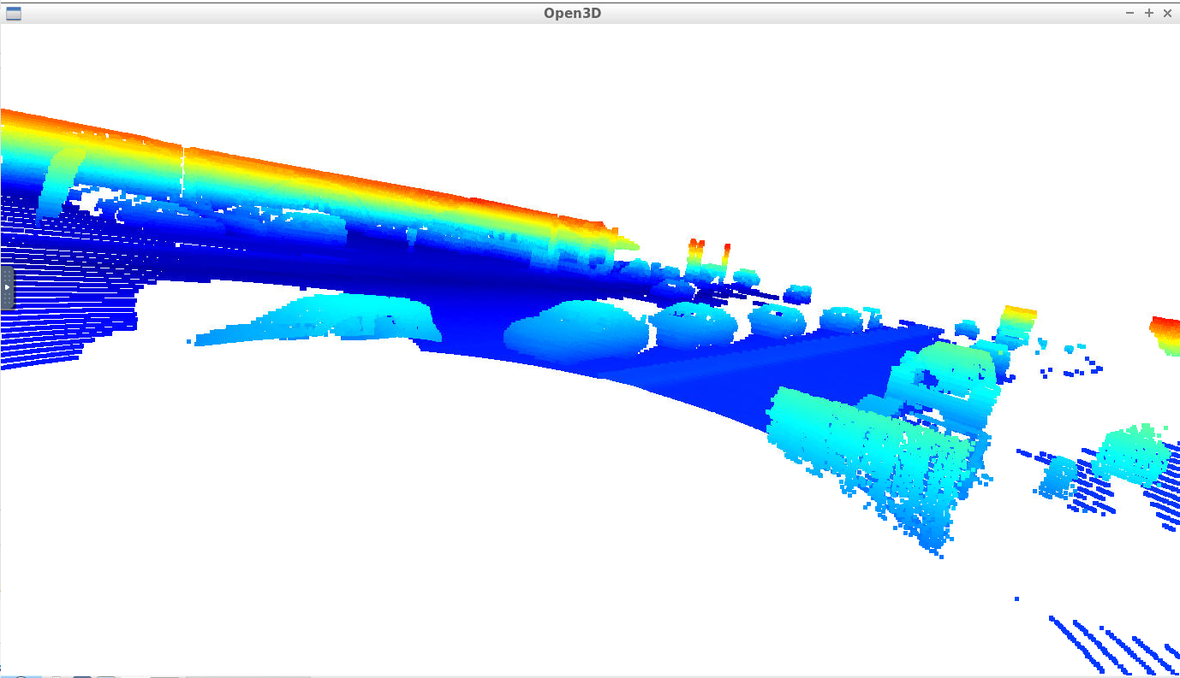

1. Similar birds eye view shapes.

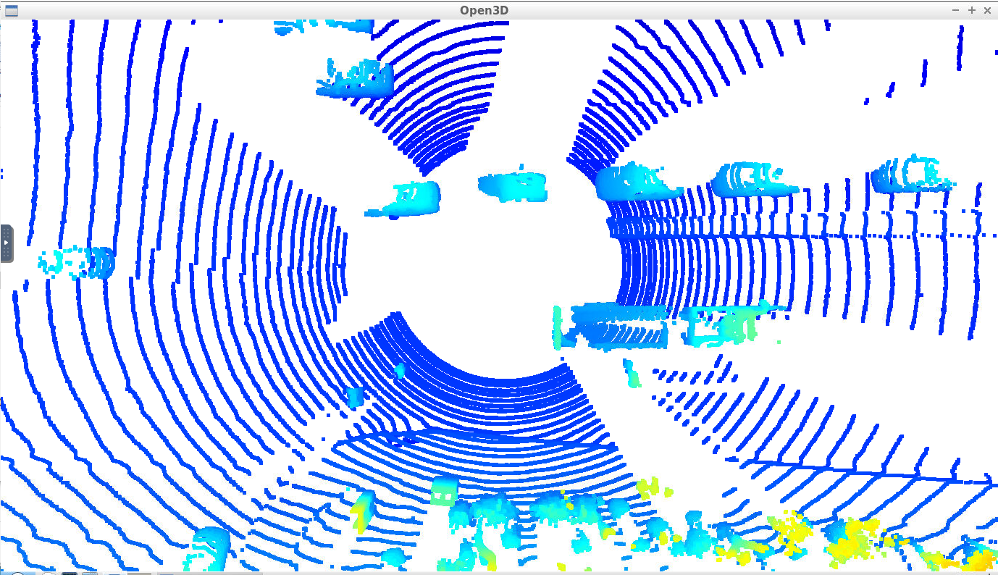

1. Similar front side windshield view



1. Similar tire shapes

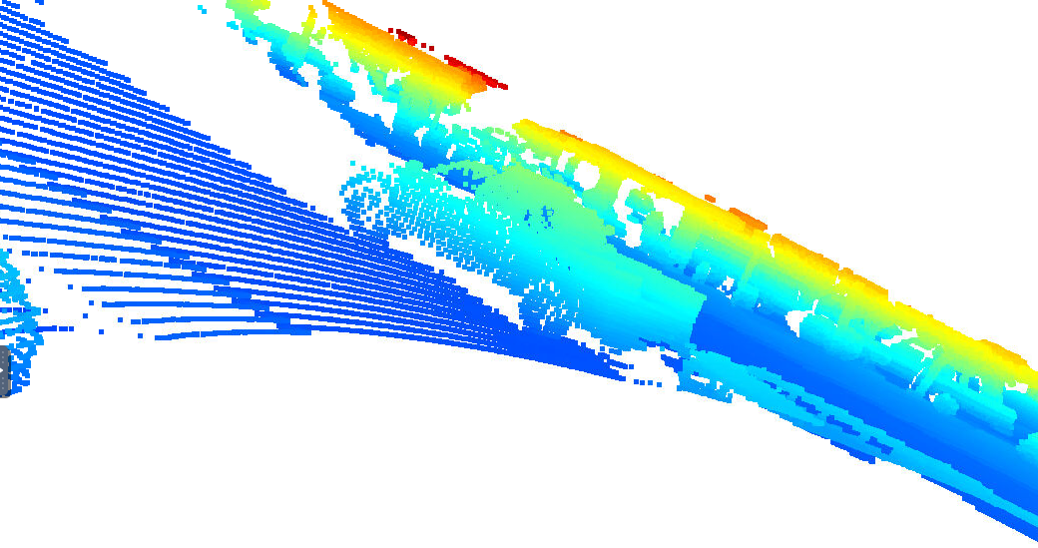

1. Similar side mirror shapes

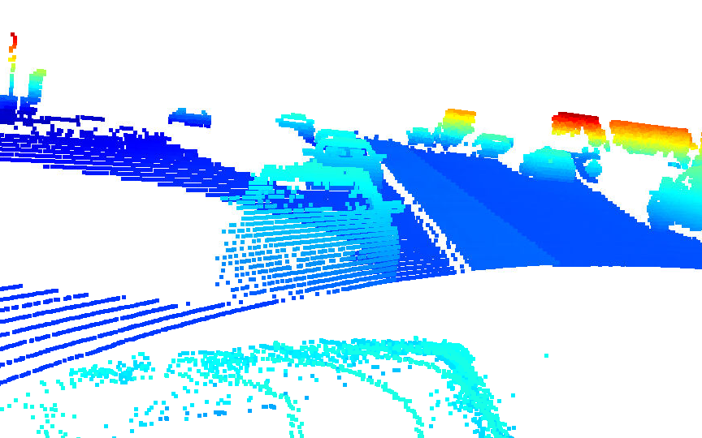

1. Similar rear bumper shapes

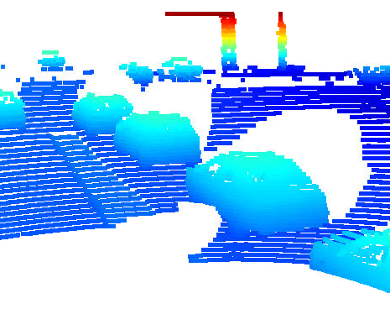

1. Similar shape of side view

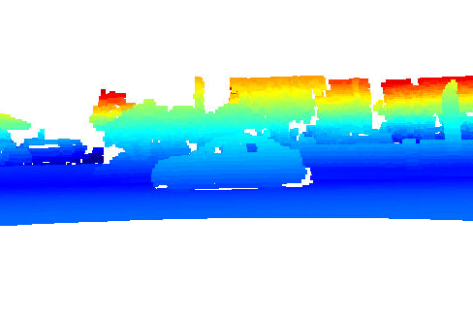

1. Similar front side windshield



1. Similar rear view car shape

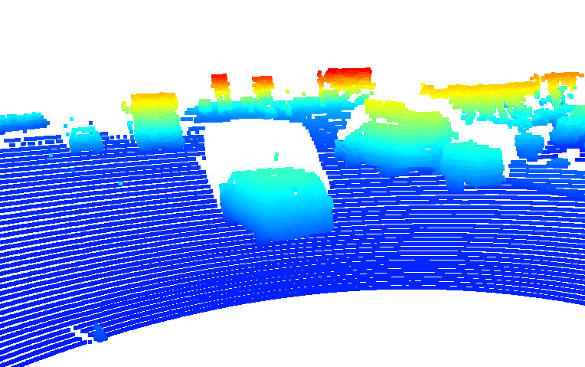

1. Similar front view of tires

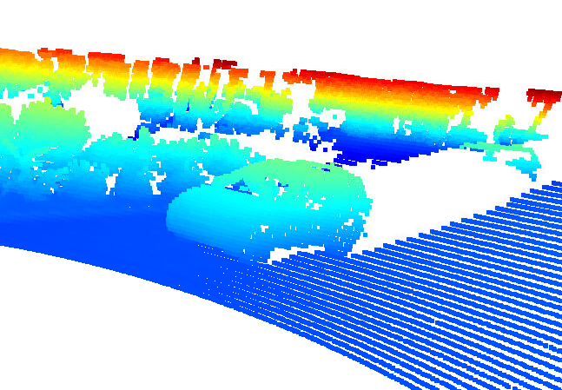

1. Strong tail light reflection intensity

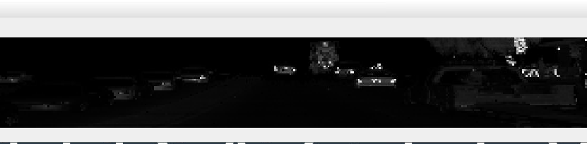

1. Clear head light, side window and tire rim

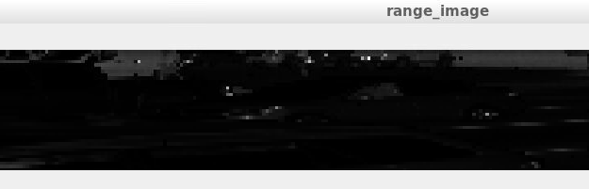

1. Strong head light and clear front side view of car frame

